**Lab6 Submission**

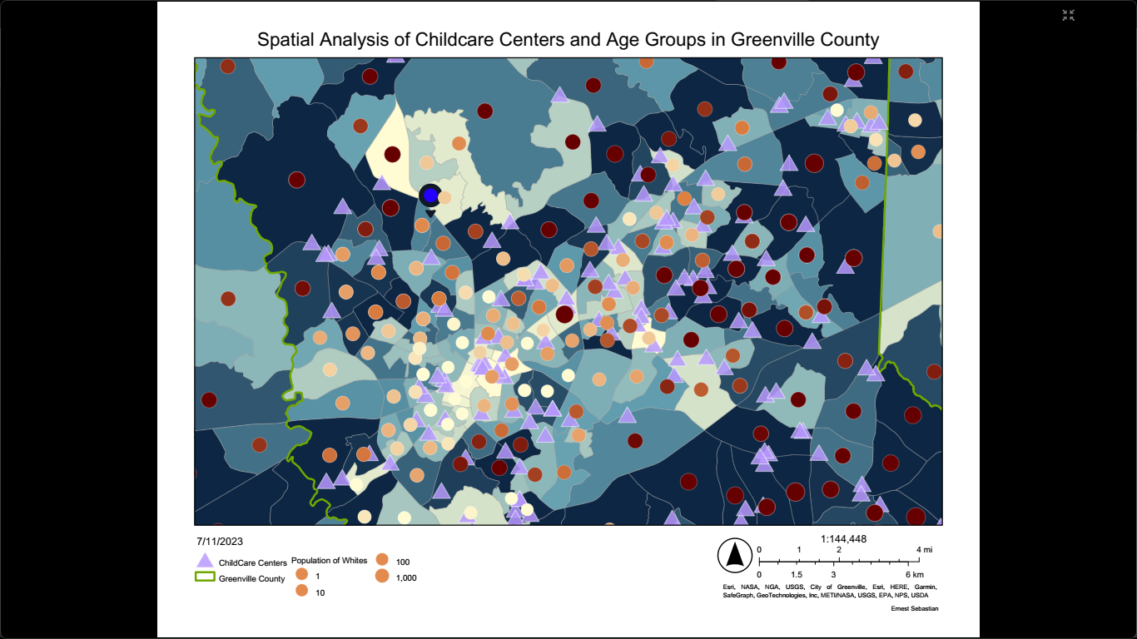

**Data Report**

Dear Client,

I have conducted an analysis of the proposed location for a new childcare facility in Greenville County, South Carolina, based on the map and demographic data. The map reveals that there are more childcare centers in areas with a lower number of infants aged 0-4, while areas with higher number of infants have fewer centers. There are several reasons that contribute to this pattern.

Firstly, the distribution of childcare centers corresponds to the demand and availability of services. Areas with more infants and fewer centers suggest that the existing facilities are meeting the demand, due to their successful operations or being large institutions with competitive pricing. This could pose a challenge for new centers to enter the market.

Additionally, accessibility plays a role in the placement of childcare centers. Areas with a higher concentration of centers in regions with fewer children aged 0-4 indicate a focus on providing convenient options for parents, even if the immediate demand might be lower. The goal is to ensure that parents have easy access to these services.

Economic considerations are also important. Areas with more infants and fewer centers may face economic challenges, making it difficult to establish or maintain childcare facilities. This can create a gap in services for the underserved population.

To determine the ideal location for the new childcare center, we need to consider several factors. Firstly, we should assess the racial and gender demographics of the area to align with the specific needs and preferences of families. This will help us cater to the desired target demographic effectively. Additionally, analyzing population density is crucial, as areas with a higher concentration of families and young children typically indicate greater demand for childcare services. Proximity to residential areas, transportation routes, and community amenities should also be considered to ensure accessibility and convenience for parents. Lastly, it is essential to conduct a competition analysis to identify areas with a scarcity of centers or unique service offerings, while also considering economic factors such as household incomes and the proportion of working parents.

In summary and by carefully examining these factors and aligning them with your business objectives, we can make an informed decision about the best location for your new childcare center which happens to be the one listed on the Map. This location is ideal, looking at the factors mentioned and how it all simply comes down to having a new childcare center facility in the location.

Please let me know if you have any further questions or if there were any additional information you would like to discuss.

Sincerely,

Ernest Sebastian.

**What I learnt in this Lab.**

During this lab, I gained valuable insights into understanding and utilizing ArcGIS Online and analyzing demographic data for decision-making. Comparing ArcGIS Online to QGIS Software, ArcGIS Online stood out for its user-friendly interface, allowing me to seamlessly incorporate various demographic datasets at an amazingly fast rate as it is direct and helped me uncover meaningful patterns in the distribution of childcare centers. Its cloud-based nature and collaborative features made it convenient for working fast without the need to install software. On the other hand, QGIS offers more flexibility and advanced analysis options, providing greater customization and offline functionality. Customization options are so flexible in QGIS than in ArcGIS Online.